|  |
| --- |
| **CONFIDENTIAL** |
| **SportVue LLC** |
| *Improving Stickhandling, Scoring, and Safety!* |
| **Business Plan** |
| Prepared 03/29/2019 |
| **Contact Information**  James Li  jamesli@hockeyvue.com  703-862-9643  www.hockeyvue.com  21421 Cliff Haven CT.  Sterling, VA 20164, USA |

Table of Contents

Executive Summary 1

Opportunity 1

Expectations 1

Opportunity 2

Problem & Solution 2

Target Market 2

Competition 2

Execution 3

Marketing & Sales 3

Operations 3

Milestones & Metrics 3

Company 4

Overview 4

Team 4

Financial Plan 5

Forecast 5

Financing 7

Statements 7

Appendix 10

Profit and Loss Statement 10

Balance Sheet 13

Cash Flow Statement 16

# Executive Summary

## Opportunity

### Problem Summary

INSTRUCTIONS: Describe very briefly why your business needs to exist. What problem do you solve for your customers?

### Solution Summary

INSTRUCTIONS: Briefly summarize what your company does. The executive summary should be very short and you can go into more detail later in the plan.

### Market

INSTRUCTIONS: Describe your target customer or market segments. Again, keep things very brief in the executive summary and add more detail later in the plan.

### Competition

INSTRUCTIONS: Summarize your key competition. Who will your customers also consider?

### Why Us?

INSTRUCTIONS: Write a brief overview of you and your team. Why are you the right people to build this business?

## Expectations

### Forecast

INSTRUCTIONS: Write a brief overview of your financial targets. How much do you plan to sell in the next year? What are your long-term sales goals?

### Financial Highlights by Year

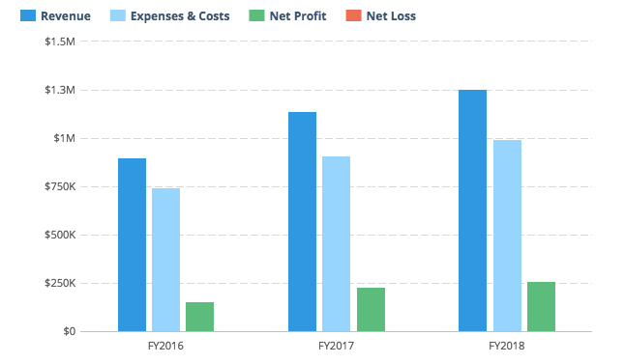

INSTRUCTIONS: Insert a chart of your key financial metrics here. Tools like [LivePlan](http://pln.rs/bptemplate) will do this for you automatically.

### Financing Needed

INSTRUCTIONS: If you are writing a business plan to raise money for your business, include a brief summary of what you are looking for. If you aren’t raising money or getting a loan, you can delete this section.

# Opportunity

## Problem & Solution

### Problem Worth Solving

Ice hockey players are taught skills such as stickhandling, shooting, passing, and skating at a very young age. However, young players have difficulty transferring these skills from practice to an actual game. This is because practices do not have the in-game pressure or the fast pace of games. As a result, players control the puck while looking down at it during practice and are unable to control the puck with only their peripheral vision during a game. If players are taught to keep their head up during practice, then they will be accustomed to doing this during a game and will be able to make better in-game decisions regarding passing, puck control, and shooting.

Additionally, players in the USA and Canada are allowed to body check starting at age 13-14. At this age, players sustain concussions because they keep their head down while skating with the puck, leaving them entirely blind to oncoming hits. Players can avoid injuries and blindside checks if they are taught to be accustomed to controlling the puck with their head up.

### Our Solution

SportVue LLC’s primary product is a sleek earpiece that uses a proprietary algorithm to detect when the player is looking down at the puck during off-ice practice. This earpiece will beep when the player looks down at the puck to remind him to lift his head up. After repeated use, the player will be accustomed to controlling the puck with his head up.

After this product is released, a second version will incorporate an IR sensor and will be used for on-ice practices that have more dynamic movements. This earpiece will clip onto the helmet’s plastic ear guard and function the same way as the primary product.

## Target Market

### Market Size & Segments

INSTRUCTIONS: Describe your key customers – who they are and what their key attributes are. If your company is targeting multiple customer groups (also called ‘segments’), describe each group here. If you can, include details about how many people are in each segment and how large the total market is.

As the pioneer of a product of this kind, SportVue LLC understands the significance of clearly identifying its target market and the preferences of its customers.

Our first market segment is based on demographic: 30 to 40-year-old, Caucasian, middle to upper class males who have a child or multiple children playing ice hockey. While this demographic is the ideal customer, the consumer of the product will be the children of these middle to upper class males. This target market should also be passionate about and actively involved in their children’s skill development and should follow the NHL.

Our second market segment is based on firmographic: ice hockey clubs and organizations that have been established for at least 5 years, with enough revenue to buy at least 20 to 40 of these devices for use during an entire team practice for all players. The ideal location of these ice hockey clubs will be in Northern USA and all parts of Canada, where ice hockey is the primary sport and the where the competitive nature of the sport will be emphasized.

We have spoken to…. And done…. And got feedback of….

## Competition

### Current Alternatives

INSTRUCTIONS: Describe your current competition. What products and services are people using instead of yours?

The closest product to our product is called “Heads Up Stickhandling” and is outdated and largely ineffective. Heads Up Stickhandling attempts to train players to keep their head up, but this product blocks the entire vision of the puck, not allowing the player to train to control the puck with his peripheral vision. Furthermore, Heads Up Stickhandling is not compatible with every existing helmet and is unattractive to wear.

Individual players and teams are using training aids that range in functionality, from orange cones to attack triangles (a product that mimics a defender’s feet and stick). These products allow the player to improve his stickhandling ability, but they do not explicitly train the player to keep his head up while controlling the puck. Similarly, training aids that focus on shooting accuracy, such as shooting targets, may improve a player’s shooting ability but do not train the player to shoot the puck with his head up.

### Our Advantages

INSTRUCTIONS: Explain why your product or service is better than the others. Also, be sure to describe any competitive advantages you may have, such as a patent or other unique component to your business.

Our product is the only ice hockey training aid on the market that does not block the user’s peripheral vision. This mimics in-game scenarios where the player can use his peripheral vision to control the puck. The player can also look down at the puck at any time while using our product, which will be necessary during the early stages of training as the player becomes accustomed to the feel of the puck. The player is not able to do this without making extreme head movements if he uses traditional products.

**possibly write about durability, sleekness, accuracy, etc.**

After our product is developed, we will file a utility patent.

# Execution

## Marketing & Sales

### Marketing Plan

INSTRUCTIONS: Explain how you plan on getting the word out about your product to your target market(s). Will you use advertising? Perhaps you are developing a content marketing strategy. Whatever your marketing plans may be, describe them here.

### Sales Plan

INSTRUCTIONS: If your company relies on sales people to close sales deals, you need a sales plan. Your sales plan should explain how you convert people who express interest in your product or service into paying customers. If you are opening a food truck, this section is less important and you can consider removing it. However, if you are starting a sales-heavy business like enterprise software or a car dealership, then you need to document how you will nurture leads and close deals.

We will have salespeople contact the board of directors of various ice hockey clubs and offer a sampling/demo of our product. We hope to acquire sales from ice hockey teams after our product demo.

## Operations

### Locations & Facilities

INSTRUCTIONS: Describe your company’s physical locations. This might be your office, store locations, manufacturing plants, storage facilities — whatever is relevant to your business. How much space do you have available, and how well will it meet your current and future needs?

### Technology

INSTRUCTIONS: Describe any important software, hardware, or other information technology that you use now or plan to use later to operate your business. That might include a point-of-sale system to take payments, an e-commerce engine for your website, a CRM solution for managing your pipeline, marketing tools for generating leads, and so on.

### Equipment & Tools

INSTRUCTIONS: List any specialty equipment that you have or plan to acquire to do your work. This is an important component of the business plan for many industrial companies.

## Milestones & Metrics

### Milestones

INSTRUCTIONS: List your key milestones and the dates that you hope to accomplish them by. If you’ve already accomplished key goals for your business, list them here as evidence that your business is getting traction – in other words, it’s getting positive attention from potential customers.

### Key Metrics

INSTRUCTIONS: Explain which performance metrics are most important for understanding how your business is doing. What does success mean for you, and how will you know it when you see it?

# Company

## Overview

INSTRUCTIONS: Use this area to specify who owns your company. If there are multiple owners, describe each of them and how much of an ownership stake they have. Also, identify your company’s legal structure. Is it a sole proprietorship — that is, just you working for yourself? Or a partnership, such as a limited-liability corporation (LLC) or partnership (LLP), where the profits pass through to the partners involved? Or a nonprofit organization? Or a proper S- or C-type corporation with its own tax obligations and the rest?

## Team

### Management Team

INSTRUCTIONS: List the members of the management team, including yourself. Describe each person’s skills and experience and what they will be doing for the company. It’s OK if you don’t have everyone for a complete management team yet. In that case, make sure to identify gaps in your team that you intend to fill over time.

### Advisors

INSTRUCTIONS: Describe any mentors, investors, former professors, industry or subject-matter experts, knowledgeable friends or family members, small-business counselors, or others who can help you as a business owner.

# Financial Plan

## Forecast

### Key Assumptions

INSTRUCTIONS: Describe how you came up with the values in your financial forecast. Did you project your revenue based on past results, market research, your best guess at how many people who visit your store and what percentage of them might buy, or some other method? What kind of growth are you assuming? What are your key hires and notable expenses? What level of profit do you expect to generate?

### Revenue by Month

INSTRUCTIONS: Include a chart that shows your projected revenue. A tool like [LivePlan](http://pln.rs/bptemplate) can help you create a chart like this and automatically include it in your business plan.

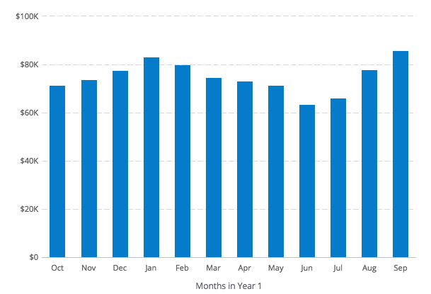

### Expenses by Month

INSTRUCTIONS: Include a chart that shows your projected expenses. A tool like [LivePlan](http://pln.rs/bptemplate) can help you create a chart like this and automatically include it in your business plan.

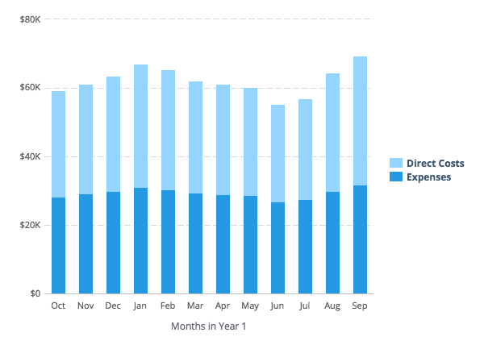

### Net Profit (or Loss) by Year

INSTRUCTIONS: Include a chart that shows your projected expenses. A tool like [LivePlan](http://pln.rs/bptemplate) can help you create a chart like this and automatically include it in your business plan.

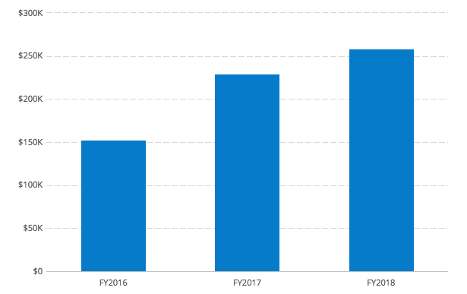

## Financing

### Use of Funds

INSTRUCTIONS: If your forecast includes loans, investments, or other financing, use this space to explain what you plan do with that money.

### Sources of Funds

INSTRUCTIONS: Describe your financing plans. Are you investing your own money in the business? Do you have a credit card or line of credit? What other types of funds — personal or business loans, equity investments from others, etc. — do you expect to receive and when? If you do not have the full detail of future financing worked out yet, that is understandable. Just explain what you do know and when you expect to sort out the details.

## Statements

### Projected Profit & Loss

INSTRUCTIONS: Provide a summary of your financial forecast here. You can certainly do this by yourself, but tools like [LivePlan](http://pln.rs/bptemplate) make it much easier.

|  |  |  |  |
| --- | --- | --- | --- |
|  | FY2018 | FY2019 | FY2020 |
| Revenue |  |  |  |
|  |  |  |  |
| Direct Costs |  |  |  |
|  |  |  |  |
| Gross Margin |  |  |  |
| Gross Margin % |  |  |  |
| Operating Expenses |  |  |  |
| Salary |  |  |  |
| Employee Related Expenses |  |  |  |
| Total Operating Expenses |  |  |  |
|  |  |  |  |
| Operating Income |  |  |  |
|  |  |  |  |
| Interest Incurred |  |  |  |
| Depreciation and Amortization |  |  |  |
| Income Taxes |  |  |  |
| Total Expenses |  |  |  |
| Net Profit |  |  |  |
| Net Profit / Sales |  |  |  |

### Projected Balance Sheet

INSTRUCTIONS: Include your balance sheet here.

|  |  |  |  |
| --- | --- | --- | --- |
|  | FY2018 | FY2019 | FY2020 |
| Cash |  |  |  |
| Accounts Receivable |  |  |  |
| Inventory |  |  |  |
| Other Current Assets |  |  |  |
| Total Current Assets |  |  |  |
|  |  |  |  |
| Long-Term Assets |  |  |  |
| Accumulated Depreciation |  |  |  |
| Total Long-Term Assets |  |  |  |
|  |  |  |  |
| Total Assets |  |  |  |
|  |  |  |  |
| Accounts Payable |  |  |  |
| Income Taxes Payable |  |  |  |
| Sales Taxes Payable |  |  |  |
| Short-Term Debt |  |  |  |
| Prepaid Revenue |  |  |  |
| Total Current Liabilities |  |  |  |
| Long-Term Debt |  |  |  |
|  |  |  |  |
| Total Liabilities |  |  |  |
|  |  |  |  |
| Paid-in Capital |  |  |  |
| Retained Earnings |  |  |  |
| Earnings |  |  |  |
| Total Owner's Equity |  |  |  |
|  |  |  |  |
| Total Liabilities & Equity |  |  |  |

### Projected Cash Flow Statement

INSTRUCTIONS: Include your cash flow statement here.

|  |  |  |  |
| --- | --- | --- | --- |
|  | FY2018 | FY2019 | FY2020 |
| Net Cash Flow from Operations |  |  |  |
| Net Profit |  |  |  |
| Depreciation and Amortization |  |  |  |
| Change in Accounts Receivable |  |  |  |
| Change in Inventory |  |  |  |
| Change in Accounts Payable |  |  |  |
| Change in Income Tax Payable |  |  |  |
| Change in Sales Tax Payable |  |  |  |
| Change in Prepaid Revenue |  |  |  |
| Net Cash Flow from Operations |  |  |  |
| Investing & Financing |  |  |  |
| Assets Purchased or Sold |  |  |  |
| Investments Received |  |  |  |
| Change in Long-Term Debt |  |  |  |
| Change in Short-Term Debt |  |  |  |
| Dividends & Distributions |  |  |  |
| Net Cash Flow from Investing & Financing |  |  |  |
| Cash at Beginning of Period |  |  |  |
| Net Change in Cash |  |  |  |
| Cash at End of Period |  |  |  |

# Appendix

## Profit and Loss Statement (With Monthly Detail)

|  |  |  |  |  |  |  |  |  |  |  |  |  |
| --- | --- | --- | --- | --- | --- | --- | --- | --- | --- | --- | --- | --- |
| FY2018 | Mar '17 | Apr '17 | May '17 | Jun '17 | Jul '17 | Aug '17 | Sep '17 | Oct '17 | Nov '17 | Dec '17 | Jan '18 | Feb '18 |
| Revenue |  |  |  |  |  |  |  |  |  |  |  |  |
|  |  |  |  |  |  |  |  |  |  |  |  |  |
| Direct Costs |  |  |  |  |  |  |  |  |  |  |  |  |
|  |  |  |  |  |  |  |  |  |  |  |  |  |
| Gross Margin |  |  |  |  |  |  |  |  |  |  |  |  |
| Gross Margin % |  |  |  |  |  |  |  |  |  |  |  |  |
| Operating Expenses |  |  |  |  |  |  |  |  |  |  |  |  |
| Salary |  |  |  |  |  |  |  |  |  |  |  |  |
| Employee Related Expenses |  |  |  |  |  |  |  |  |  |  |  |  |
| Total Operating Expenses |  |  |  |  |  |  |  |  |  |  |  |  |
|  |  |  |  |  |  |  |  |  |  |  |  |  |
| Operating Income |  |  |  |  |  |  |  |  |  |  |  |  |
|  |  |  |  |  |  |  |  |  |  |  |  |  |
| Interest Incurred |  |  |  |  |  |  |  |  |  |  |  |  |
| Depreciation and Amortization |  |  |  |  |  |  |  |  |  |  |  |  |
| Income Taxes |  |  |  |  |  |  |  |  |  |  |  |  |
| Total Expenses |  |  |  |  |  |  |  |  |  |  |  |  |
| Net Profit |  |  |  |  |  |  |  |  |  |  |  |  |
| Net Profit / Sales |  |  |  |  |  |  |  |  |  |  |  |  |

## Profit and Loss Statement (Annual Detail)

|  |  |  |  |
| --- | --- | --- | --- |
|  | FY2018 | FY2019 | FY2020 |
| Revenue |  |  |  |
|  |  |  |  |
| Direct Costs |  |  |  |
|  |  |  |  |
| Gross Margin |  |  |  |
| Gross Margin % |  |  |  |
| Operating Expenses |  |  |  |
| Salary |  |  |  |
| Employee Related Expenses |  |  |  |
| Total Operating Expenses |  |  |  |
|  |  |  |  |
| Operating Income |  |  |  |
|  |  |  |  |
| Interest Incurred |  |  |  |
| Depreciation and Amortization |  |  |  |
| Income Taxes |  |  |  |
| Total Expenses |  |  |  |
| Net Profit |  |  |  |
| Net Profit / Sales |  |  |  |

## Balance Sheet (With Monthly Detail)

|  |  |  |  |  |  |  |  |  |  |  |  |  |
| --- | --- | --- | --- | --- | --- | --- | --- | --- | --- | --- | --- | --- |
| FY2018 | Mar '17 | Apr '17 | May '17 | Jun '17 | Jul '17 | Aug '17 | Sep '17 | Oct '17 | Nov '17 | Dec '17 | Jan '18 | Feb '18 |
| Cash |  |  |  |  |  |  |  |  |  |  |  |  |
| Accounts Receivable |  |  |  |  |  |  |  |  |  |  |  |  |
| Inventory |  |  |  |  |  |  |  |  |  |  |  |  |
| Other Current Assets |  |  |  |  |  |  |  |  |  |  |  |  |
| Total Current Assets |  |  |  |  |  |  |  |  |  |  |  |  |
|  |  |  |  |  |  |  |  |  |  |  |  |  |
| Long-Term Assets |  |  |  |  |  |  |  |  |  |  |  |  |
| Accumulated Depreciation |  |  |  |  |  |  |  |  |  |  |  |  |
| Total Long-Term Assets |  |  |  |  |  |  |  |  |  |  |  |  |
|  |  |  |  |  |  |  |  |  |  |  |  |  |
| Total Assets |  |  |  |  |  |  |  |  |  |  |  |  |
|  |  |  |  |  |  |  |  |  |  |  |  |  |
| Accounts Payable |  |  |  |  |  |  |  |  |  |  |  |  |
| Income Taxes Payable |  |  |  |  |  |  |  |  |  |  |  |  |
| Sales Taxes Payable |  |  |  |  |  |  |  |  |  |  |  |  |
| Short-Term Debt |  |  |  |  |  |  |  |  |  |  |  |  |
| Prepaid Revenue |  |  |  |  |  |  |  |  |  |  |  |  |
| Total Current Liabilities |  |  |  |  |  |  |  |  |  |  |  |  |
| Long-Term Debt |  |  |  |  |  |  |  |  |  |  |  |  |
|  |  |  |  |  |  |  |  |  |  |  |  |  |
| Total Liabilities |  |  |  |  |  |  |  |  |  |  |  |  |
|  |  |  |  |  |  |  |  |  |  |  |  |  |
| Paid-in Capital |  |  |  |  |  |  |  |  |  |  |  |  |
| Retained Earnings |  |  |  |  |  |  |  |  |  |  |  |  |
| Earnings |  |  |  |  |  |  |  |  |  |  |  |  |
| Total Owner's Equity |  |  |  |  |  |  |  |  |  |  |  |  |
|  |  |  |  |  |  |  |  |  |  |  |  |  |
| Total Liabilities & Equity |  |  |  |  |  |  |  |  |  |  |  |  |

## Balance Sheet (Annual Detail)

|  |  |  |  |
| --- | --- | --- | --- |
|  | FY2018 | FY2019 | FY2020 |
| Cash |  |  |  |
| Accounts Receivable |  |  |  |
| Inventory |  |  |  |
| Other Current Assets |  |  |  |
| Total Current Assets |  |  |  |
|  |  |  |  |
| Long-Term Assets |  |  |  |
| Accumulated Depreciation |  |  |  |
| Total Long-Term Assets |  |  |  |
|  |  |  |  |
| Total Assets |  |  |  |
|  |  |  |  |
| Accounts Payable |  |  |  |
| Income Taxes Payable |  |  |  |
| Sales Taxes Payable |  |  |  |
| Short-Term Debt |  |  |  |
| Prepaid Revenue |  |  |  |
| Total Current Liabilities |  |  |  |
| Long-Term Debt |  |  |  |
|  |  |  |  |
| Total Liabilities |  |  |  |
|  |  |  |  |
| Paid-in Capital |  |  |  |
| Retained Earnings |  |  |  |
| Earnings |  |  |  |
| Total Owner's Equity |  |  |  |
|  |  |  |  |
| Total Liabilities & Equity |  |  |  |

## 

## Cash Flow Statement (With Monthly Detail)

|  |  |  |  |  |  |  |  |  |  |  |  |  |
| --- | --- | --- | --- | --- | --- | --- | --- | --- | --- | --- | --- | --- |
| FY2018 | Mar '17 | Apr '17 | May '17 | Jun '17 | Jul '17 | Aug '17 | Sep '17 | Oct '17 | Nov '17 | Dec '17 | Jan '18 | Feb '18 |
| Net Cash Flow from Operations |  |  |  |  |  |  |  |  |  |  |  |  |
| Net Profit |  |  |  |  |  |  |  |  |  |  |  |  |
| Depreciation and Amortization |  |  |  |  |  |  |  |  |  |  |  |  |
| Change in Accounts Receivable |  |  |  |  |  |  |  |  |  |  |  |  |
| Change in Inventory |  |  |  |  |  |  |  |  |  |  |  |  |
| Change in Accounts Payable |  |  |  |  |  |  |  |  |  |  |  |  |
| Change in Income Tax Payable |  |  |  |  |  |  |  |  |  |  |  |  |
| Change in Sales Tax Payable |  |  |  |  |  |  |  |  |  |  |  |  |
| Change in Prepaid Revenue |  |  |  |  |  |  |  |  |  |  |  |  |
| Net Cash Flow from Operations |  |  |  |  |  |  |  |  |  |  |  |  |
| Investing & Financing |  |  |  |  |  |  |  |  |  |  |  |  |
| Assets Purchased or Sold |  |  |  |  |  |  |  |  |  |  |  |  |
| Investments Received |  |  |  |  |  |  |  |  |  |  |  |  |
| Change in Long-Term Debt |  |  |  |  |  |  |  |  |  |  |  |  |
| Change in Short-Term Debt |  |  |  |  |  |  |  |  |  |  |  |  |
| Dividends & Distributions |  |  |  |  |  |  |  |  |  |  |  |  |
| Net Cash Flow from Investing & Financing |  |  |  |  |  |  |  |  |  |  |  |  |
| Cash at Beginning of Period |  |  |  |  |  |  |  |  |  |  |  |  |
| Net Change in Cash |  |  |  |  |  |  |  |  |  |  |  |  |
| Cash at End of Period |  |  |  |  |  |  |  |  |  |  |  |  |

## Cash Flow Statement (Annual Detail)

|  |  |  |  |
| --- | --- | --- | --- |
|  | FY2018 | FY2019 | FY2020 |
| Net Cash Flow from Operations |  |  |  |
| Net Profit |  |  |  |
| Depreciation and Amortization |  |  |  |
| Change in Accounts Receivable |  |  |  |
| Change in Inventory |  |  |  |
| Change in Accounts Payable |  |  |  |
| Change in Income Tax Payable |  |  |  |
| Change in Sales Tax Payable |  |  |  |
| Change in Prepaid Revenue |  |  |  |
| Net Cash Flow from Operations |  |  |  |
| Investing & Financing |  |  |  |
| Assets Purchased or Sold |  |  |  |
| Investments Received |  |  |  |
| Change in Long-Term Debt |  |  |  |
| Change in Short-Term Debt |  |  |  |
| Dividends & Distributions |  |  |  |
| Net Cash Flow from Investing & Financing |  |  |  |
| Cash at Beginning of Period |  |  |  |
| Net Change in Cash |  |  |  |
| Cash at End of Period |  |  |  |